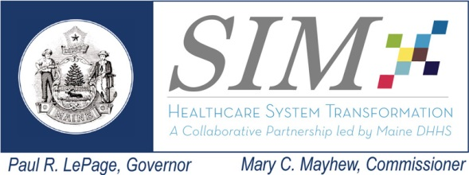  This work is made possible with funding from the Maine State Innovation Model Initiative | Workgroup: Accountable Care Implementation (ACI)  Date: July 21, 2015  Time: 3:00 to 5:00 pm  Location: Maine Medical Association, Manchester  Remote Access: See GoToMeeting link below
Agenda

Meeting Objectives: Provide an update on public reporting of TCI, status of Measure Alignment work, update on primary care spend benchmark, present findings and recommendations of Bailit Health interviews with health plans, and brief the Steering Committee on CMS announcement of potential expansion of CPCI.
Topics Lead Time
- Welcome and meeting overview |  | Frank Johnson | 3:00 – 3:10
- Public Reporting of TCI on GetBetterMaine |  | Brandon Hotham | 3:10 – 3:30
- Update/status of Measure Alignment Work Group |  | Frank Johnson | 3:30 – 3:40
- Update on Primary Care Spend Benchmark |  | Frank Johnson | 3:40 – 3:50
- Findings and recommendations of Bailit Health interviews with payers on key primary care payment definitions |  | Frank Johnson | 3:50 – 4:40
- CMS announcement on potential expansion of CPCI |  | Lisa Letourneau | 4:40 – 4:50
- Other business

ACI Steering Committee

ACI Session

Tue, Jul 21, 2015 3:00 PM - 5:00 PM Eastern Daylight Time
Please join my meeting from your computer, tablet or smartphone.
https://global.gotomeeting.com/join/313084701
You can also dial in using your phone.
United States : +1 (571) 317-3112
Access Code: 313-084-701

